|  |
| --- |
| Smart Purchase Card |
| Concept to Smart Card introducing to purchase items in shops and restaurants. |

Contents

Sequence Diagram Story 3

Class Diagram 6

Application User Interfaces 7

# Sequence Diagram Story

Customer->Counter: Enter to shop

note right of Counter: Counter gives a UserCard

Customer->Table: Goes to a table

alt New APP User

Customer->Customer: Scans the APPQR from UserCard

else Existing APP User

Customer->Customer: Open the App already installed

end

note right of Customer: AppQR is on the backside of UserQR

Customer->App: Customer opens the App.

note right of AppCart: [].

App->AppCart: Select the order

note left of AppCart: Customer Select Items

note right of AppCart: [item1, item2, item3]

Customer->App: Submiting Cart to do the order

note right of AppCart: [item1, item2, item3]

App->AppCart: Request Submission

note right of AppCart: [item1, item2, item3]

AppCart->App: Returns SelectedItems

App->Customer: Request CustomerQR to proceed

Customer->App: Submit CustomerQR

note right of Customer: CustomerQR is in UserCard

App->Customer: Request TableQR to proceed

Customer->App: Submit TableQR

note right of Customer: TableQR is in on the table

note right of Customer: Customer needs to scan it from table

App->Kichen: Request Sends to Kichen

note right of Kichen: [item1, item2, item3]

Kichen->Table: Delivery the product

note right of Table: [item1, item2, item3]

Customer->Counter: Leaving the shop

Counter->Customer: Request the UserCard

Customer->Counter: Gives the Usershop

Counter->Customer: Check the Item Purchased. and give the bill.

Customer->Counter: pay the bill

<https://www.websequencediagrams.com/#open=378919>

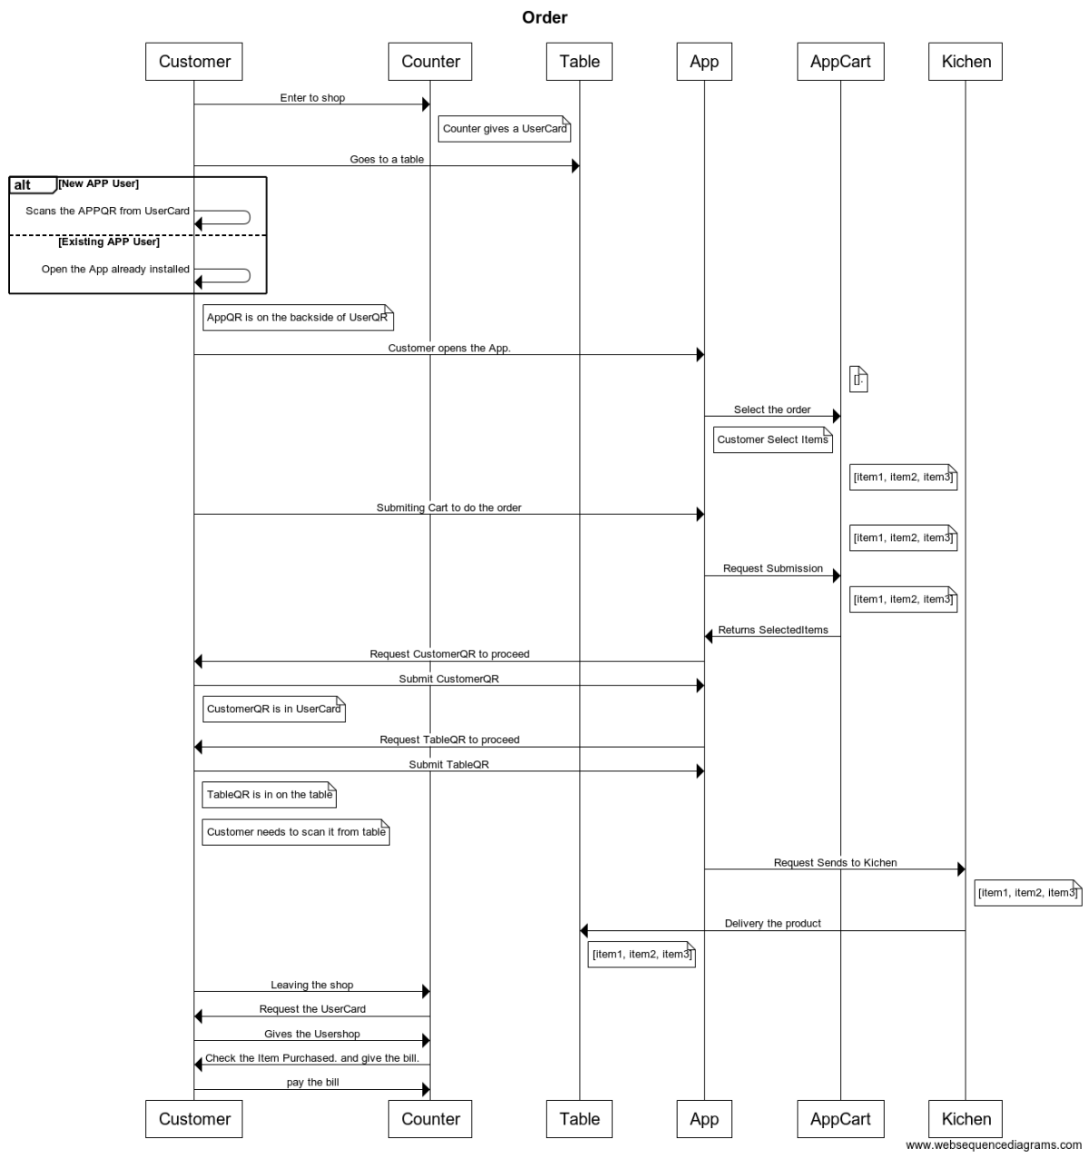

# Class Diagram

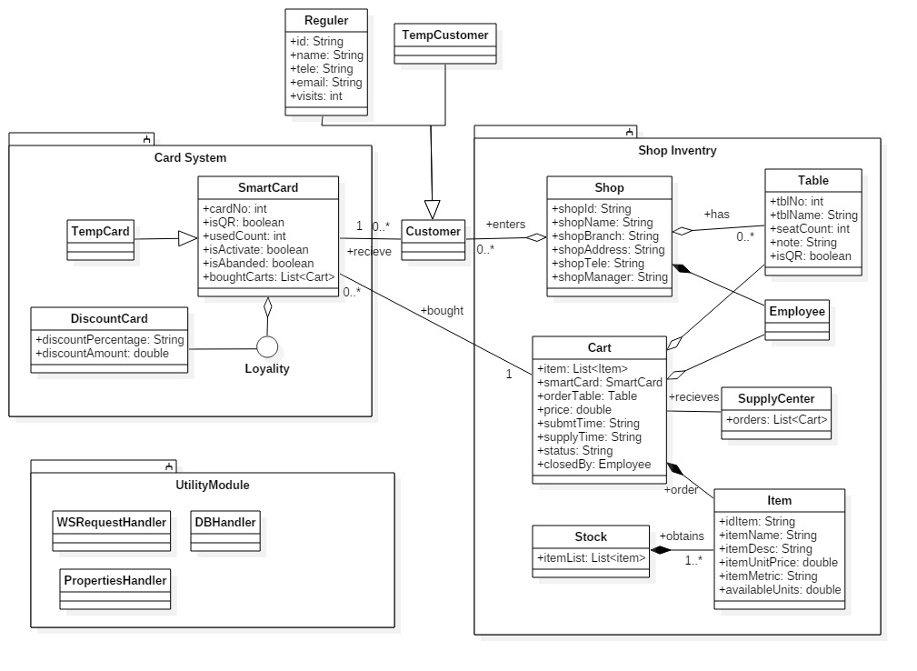

# Application User Interfaces

S